Administrative Information
School |  | Department
PI name |  | PI email
Lab manager name (if applicable) |  | Lab manager email (if applicable)
Locations covered by this SOP (buildings/rooms)
SOP version number |  | SOP approval date
Reviewed and approved by (name) |  | Reviewed and approved by (initials)
Emergency contact name |  | Emergency contact phone*
Secondary emergency contact name |  | Secondary emergency contact phone*
* Provide emergency contact phone numbers that will be active both during normal work hours and after hours, e.g., personal mobile phone. Alternatively, give separate daytime and after-hours numbers for both contacts.

SOP Requirements
Instructions Document | You are responsible for reading the SOP Instructions outlining roles, responsibilities, and other important safety information. In addition, you must include that document as part of your records.
Recordkeeping | Acknowledgement forms for this SOP and any associated training are included at the end of this document. Additional copies of the forms are available online (SOP Acknowledgement, Internal Training Record).
Customization | It is intended that personnel add lab-specific information to the SOP template to produce a finished and functional SOP. Suggested places to add customization are highlighted in yellow throughout the document.

Standard (Safe) Operating Procedure:
HYDROFLUORIC ACID & Hydrofluoric Acid Precursors
This SOP is lengthy due to the exceptionally grave hazards posed by hydrofluoric acid and hydrogen fluoride. It is ESSENTIAL that all HF users take time to thoroughly read and understand this document.
Scope | This SOP covers the following materials:  Hydrogen fluoride (HF)  Hydrofluoric acid (i.e. aqueous HF)  Substances which easily hydrolyze to HF (e.g. DAST, many non-metal fluorides, many high oxidation state metal fluorides)  Hydrogen fluoride pyridine (Olah’s reagent), triethylamine trihydrofluoride, DMPU-HF reagent, other non-aqueous hydrogen fluoride complexes and solutions  Mixtures which contain HF (e.g. buffered oxide etch, acidified solutions of ionic fluorides, glass etching paste, Wright etch)  - Bifluorides (e.g. ammonium bifluoride (ammonium hydrogen fluoride, ammonium hydrogen difluoride))
Nomenclature | Although strictly speaking, “HF” refers to hydrogen fluoride and “HF_{(aq)}” refers to hydrofluoric acid, common practice is to use HF rather indiscriminately to denote either the anhydrous compound or the aqueous acid. In this SOP, HF is used to denote the compound hydrogen fluoride without reference to whether it is pure or dissolved in water or some other solvent. Where the pure material is specifically intended, it will be referred to as anhydrous hydrogen fluoride. The aqueous solution will be called hydrofluoric acid.  All % concentrations are % by weight.
Properties & Hazards | Anhydrous hydrogen fluoride is a highly corrosive, toxic, volatile liquid or gas (boiling point 19.5 °C), usually supplied in steel cylinders. When dissolved in water, it forms hydrofluoric acid, a highly toxic, corrosive solution. Due to the high strength of Si-F bonds, HF has an almost unique ability to dissolve silica and related materials (e.g. glass) at room temperature. In USC laboratories, the principal use of hydrofluoric acid is as an etchant.  A common misapprehension is that HF is an exceptionally strong acid. While it is true that anhydrous hydrogen fluoride does possess unusually strong acid properties, the more common hydrofluoric acid (i.e. aqueous HF) is a WEAK acid, only slightly stronger than acetic acid. The weakness of HF as an acid in aqueous solution is a key component of its extreme hazard — most of the HF in hydrofluoric acid exists as neutral undissociated molecules, and the small polar HF molecule readily absorbs into and penetrates skin.  In all forms, HF rapidly penetrates human tissue by all routes of exposure (skin contact, inhalation, ingestion). In the body, HF exists in equilibrium with fluoride ions, which are TOXIC. Fluoride binds to calcium and magnesium ions, essential to cellular function, and precipitates the ions as insoluble fluorides. Local toxicity leads to a chemical burn, which may be of extreme severity, and may result in loss of digits or limbs. If enough fluoride is absorbed, systemic toxicity may ensue, which is often fatal.
Hazard and Classification | Under the OSHA (GHS) Hazard Communication Standard, which governs product labelling and safety data sheets (SDSs), the hazard classification for hydrofluoric acid (48% concentration) is as follows:  Acute toxicity, Oral (Category 2)  Acute toxicity, Inhalation (Category 2)  Acute toxicity, Dermal (Category 1)  Skin corrosion (Category 1A)  Serious eye damage (Category 1)  Hydrofluoric acid is in the most hazardous categories for skin corrosion, eye damage, and dermal toxicity and is highly toxic orally and by inhalation.  Refer to Section 6 of the Chemical Hygiene Plan (CHP) for details of the OSHA/GHS hazard classification system. All personnel who agree to abide by this SOP are required to familiarize themselves with the contents of Section 6 of the CHP.
PHS | Due to its high acute toxicity, hydrofluoric acid is considered a Particularly Hazardous Substance (PHS) by Cal-OSHA (8 CCR §5191 (e) (H)). PHS must to be handled with special care. Please refer to the CHP (Sections 6 and 8) for more information on the classification and identification of PHS, and safe practices for working with these materials.
Effects of Exposure | Toxic effects and symptoms of hydrofluoric acid exposure (via liquid, spray, or vapor) may include:  Skin contact – Severe, deep burns due to tissue death. Burns may not appear until hours after the exposure. Ion imbalances (due to precipitation of Ca/Mg) often cause sensory nerve malfunction, leading to extreme pain.  Eyes – Eye irritation at low exposure, progressing to burns, corneal opacity, and potential destruction of the eye at higher exposures.  Respiratory tract – Irritation at low exposure, progressing to coughing, chest tightness, choking due to constriction of airway, internal burns, and pulmonary edema (fluid in lungs) at higher exposures. Pulmonary edema may be delayed up to two days and may be fatal.  Systemic – Numerous effects, largely due to low calcium levels (hypocalcemia), including heart arrhythmia, cardiac arrest, collapse, and death. This may occur from any route of HF exposure if absorbed in sufficient quantities.  Residual injury – Scarring, finger loss, limb amputation, blindness, bronchitis.  Fatal HF exposures have occurred from: (1) Burns over 25 in² (a five inch square; 160 cm²); (2) Burns from ≥50% concentration hydrofluoric acid to at least 1% of the surface area of the body (equivalent to about the area of a palm); (3) Hydrofluoric acid burns covering at least 5% of the body surface area, regardless of the acid concentration; (4) Inhalation of hydrogen fluoride vapor, especially the high concentrations evolved by very concentrated (≥60%) aqueous acid.
Available Concentrations | Hydrofluoric acid is generally sold at concentrations of 40%, 48-50%, and less commonly 70%. Hydrofluoric acid above 50% concentration is OUTSTANDINGLY HAZARDOUS and should NOT be purchased unless there is an overriding technical reason why ≤50% acid cannot be used. Please inform labsafety@usc.edu in advance if hydrofluoric acid of >50% concentration is required.
Concentration &  Burn Delay | Hydrofluoric acid concentration affects how long it takes for symptoms to develop after skin contact. Above 50% concentration, visible skin changes (redness or blanching) and pain occur rapidly. At 20-50% concentration, pain and visible skin changes may be delayed 1-8 hours. Below 20% concentration, symptoms may be delayed up to 24 hours. At any concentration, a symptomless delay may be followed by an extremely severe burn and possibly systemic poisoning; therefore, HF exposure is always to be considered a medical emergency, even if initial symptoms are absent or mild.
Vapor Over  Hydrofluoric Acid | The partial vapor pressure of hydrogen fluoride over aqueous hydrofluoric acid increases disproportionally with increasing concentration and temperature. In a warm room at 80 °F (26.7 °C), the approximate equilibrium pressures of hydrogen fluoride vapor vary as follows:  Concentration of hydrofluoric acid / wt. % Equilibrium pressure of hydrogen fluoride vapor at 80 °F (26.7 °C) / mmHg (rounded values)  20 <1  30 2  40 10  50 40  70 200  Note that the legal exposure limit for hydrogen fluoride vapor is 0.4 parts per million by volume (ppm) for a working day, and the short term (15 minute) limit is 1 ppm. A partial pressure of 1 mm Hg is equivalent to about 1320 ppm, so even dilute hydrofluoric acid has the capacity to produce extremely hazardous vapor concentrations. Exposure to vapor from commercial strength hydrofluoric acid may cause rapid or immediate injury.
Note on Ionic Fluorides | Soluble ionic fluorides such as NaF, KF, and NH₄F are acutely toxic if ingested or inhaled due to the toxicity of fluoride ion. They are toxic by skin contact as some fluoride can be absorbed, but the hazard to skin is much lower than for HF as they are not classified as corrosive to skin. However, if a solution of an ionic fluoride is acidified, free HF is formed which penetrates skin much faster than ionic fluoride. Acidic solutions of ionic fluorides contain HF and display all the attendant hazards.
Undergraduate Use  of HF | In general, undergraduates shall NOT use anhydrous HF or hydrofluoric acid (including hydrofluoric acid-containing mixtures such as buffered oxide etch). In particular, undergraduates shall NOT use hydrogen fluoride containing mixtures which are easily spillable on account of being liquid, as opposed to gels or pastes.  Undergraduate use of certain lower hazard HF-containing materials may be appropriate under highly controlled conditions (e.g. small-scale use of glass etching pastes manufactured for artistic purposes).  This must include the provision of close supervision by suitably experienced and knowledgeable staff or faculty.  The staff or faculty with direct oversight responsibility shall assess the hazards and risk and shall determine whether sufficient safety controls and supervision can be provided to ensure safety. If suitable controls and supervision cannot be provided, or if there is any uncertainty, HF-containing materials shall not be used. Risk assessments, safety training, and SOPs shall be documented. Please email labsafety@usc.edu if more information is required.
Specific Substances | [Add details of specific substances you will be using in the lab under this SOP.]
Designated Work Areas/ Signage | Work with HF in any form should be at a designated area (normally a fume hood) within the lab. The designated area shall be clearly signed “Danger!—Hydrofluoric Acid (HF)” (or equivalent wording). If highly hazardous work is being performed, additional signage giving the name of the responsible individual and contact number is also recommended.  Hydrofluoric acid shall ONLY be used in areas with non-absorbent work surfaces.  HF vapor etches glass surfaces and renderers them frosted and translucent. Regular use of hydrofluoric acid in a normal fume hood will eventually cause the glass sash to irreversibly lose its transparency. Hydrofluoric acid is preferably used in an acid hood specifically designed for this purpose, with a polycarbonate sash.  [Add lab-specific work area and signage information here, if needed.]
Unattended Experiments | Unattended hazardous experiments should be signed according to the requirements of the Unattended Experiments Fact Sheet.
Storage Requirements | Hydrofluoric acid should be stored below eye level in cool, dry well-ventilated areas away from sunlight, heat, and combustibles in an upright and tightly closed manner. In addition, based on its hazard, hydrofluoric acid should always be stored in appropriately labeled secondary containment.  Hydrofluoric acid shall be stored only in chemically compatible physically tough plastic containers (normally polyethylene or PTFE). Glass containers shall NOT be employed as they will be corroded and may fail. Metal containers shall NOT be used as they may be corroded with evolution of hydrogen. Refer to the CHP (Section 7) for further information on storage and inventory-keeping requirements.
Anhydrous HF Cylinder Hazard | [You may delete this section if you do not use anhydrous hydrogen fluoride]  Anhydrous hydrogen fluoride cylinders contain liquid HF under its own vapor pressure, which is low compared to most other liquefied gases (only 776 mmHg at 70 °F (21.1 °C)). Therefore, the cylinder pressure should only be on the order of 1 psi or less (relative to atmospheric pressure), depending on ambient temperature. Anhydrous hydrogen fluoride has been known to internally corrode steel cylinders on prolonged storage, producing hydrogen with concomitant pressure rise. Immense hydrogen pressure may result, sufficient to explode the cylinder, an event of the utmost danger. For reference, a lecture bottle of anhydrous hydrogen fluoride exploded at UCSB in an unoccupied lab causing extensive damage.  To avoid hydrogen pressurization hazards, anhydrous hydrogen fluoride cylinders shall be stored in accordance with manufacturers’ recommendations. Anhydrous HF cylinders should generally not be stored longer than two years and should be returned to the vendor at the end of that time even if unused. Longer storage may be permissible if the pressure is regularly tested and logged, and there is no abnormal rise indicating internal corrosion. Please check with the cylinder vendor for their recommendation on this practice. Any pressure increase (above the expected vapor pressure of anhydrous HF) is cause to either return the cylinder to the vendor or to safely vent the hydrogen. If venting of hydrogen is contemplated, contact labsafety@usc.edu in advance for guidance.  Labs using anhydrous hydrogen fluoride shall inventory cylinders in a manner which assures individual cylinders are uniquely identified. The date of cylinder acquisition from the original vendor shall be recorded. Inventories shall be regularly reviewed to identify over-age cylinders.  [Please customize this section with a lab-specific management plan for storage and monitoring of anhydrous hydrogen fluoride cylinders.]
Labeling | ALL hydrofluoric acid vessels shall be clearly labelled even if they are in active use. (Exceptions may be made for measuring cylinders or beakers which are only used to transfer the acid and which are thoroughly washed and decontaminated immediately after use.)  Label storage cabinets and secondary containment by the words “Corrosive” and “Acute Toxicant”. Label templates are available at the Chemical Labeling and Signage web page. Refer to CHP (Section 5) for detailed requirements on hazardous materials labeling.  It is recommended to label cabinets “Danger—Hydrofluoric Acid (HF)”.
Personal Protective Equipment | Appropriate PPE shall be worn for all work with hazardous materials, in accordance with the USC Minimum Standard, CHP, and fact sheets. Appropriate PPE selection is particularly critical for HF work, due to the exceptional hazards posed by this material.  Eye protection should consist of chemical splash goggles. A face shield should be worn over goggles to protect the face. Contact lenses shall NOT be worn. Safety glasses are NOT an acceptable substitute for goggles when handling hydrofluoric acid or HF.  A lab coat shall be worn, minimum 100% cotton. Snap fastenings are preferable to buttons as they allow the lab coat to be removed quickly if hydrofluoric acid is spilled or splashed. When handling more than a few mL of concentrated acid (e.g. when decanting from a stock bottle), a chemical resistant apron should be worn over the lab coat. Regular aprons are “bib style”, which leave the arms and upper chest exposed. Thus, chemical resistant “sleeve aprons” which protect the arms and torso up to the neck are a more appropriate choice. Sleeve aprons made from Honeywell® Silver Shield® laminate film are available from various vendors (e.g. VWR, Grainger).  If handling large quantities of acid, chemical resistant foot protection is recommended in addition to acid resistant leg and body protection (either a coverall or leg protection plus sleeve apron). The leg protection should overlap the top of the foot protection on the outside so spilled acid cannot reach feet. Chemical resistant foot protection may consist of rubber boots or chemical resistant (e.g. Silver Shield® laminate film) boot covers which fit over regular footwear (e.g. Grainger # 3RVZ6).  For reasons of safety and regulatory compliance, respirator usage is NOT permitted outside of the USC Respiratory Protection Program. As a general rule, HF work which requires respiratory protection is too hazardous to conduct in USC facilities. Experiments should be redesigned to eliminate the respiratory hazard by using appropriate engineering safety controls, e.g. fume hoods. If the respiratory hazard cannot be completely eliminated by engineering safety controls and respiratory protection may be needed, please contact injuryprevention@usc.edu.  Hand protection is critical when working with hydrofluoric acid. Thus, appropriate glove selection and usage is ESSENTIAL. Glove selection is not straightforward as different glove materials have resistance to different chemicals and vary in their flexibility and elasticity and thus in the dexterity they allow. There is a trade-off between dexterity and mechanical/chemical protection.  The following sections provide information to assist in making an informed decision and should be read carefully.  Hand protection may be combined with laminate film or neoprene chemical resistant sleeves to better protect the arms (e.g. Grainger # 5T476 (Honeywell® Silver Shield® laminate film; Figure 1, below) or Grainger # 5EME3 (neoprene; Ansell® 59-050)).  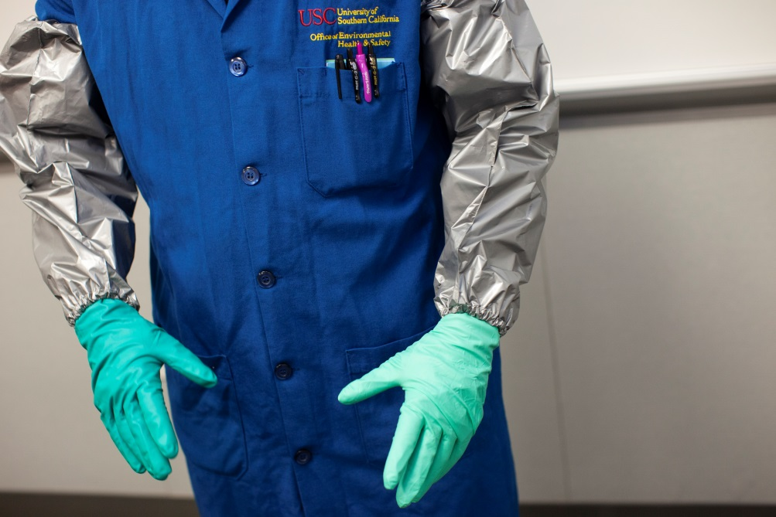  Figure 1. Butyl inner gloves (not visible). Neoprene (right) or nitrile/neoprene double layer (left) outer gloves. Honeywell® Silver Shield® laminate film arm protectors (Grainger # 5T476). The lab coat pictured is an old-style Nomex® coat with buttons. Lab coats with snap fastenings are preferable when using hydrofluoric acid as they can be removed more quickly in an emergency.  Remove finger rings before working with hydrofluoric acid. In part to avoid sharp edged jewelry from damaging gloves as well as to avoid the extra problem of removing rings in the event of an HF burn.  [Add details of any lab- or procedure-specific PPE rules/requirements.]
PPE: Glove Materials | All glove materials have limitations as to what materials they protect against. Glove manufacturers’ chemical resistance guides should be consulted carefully when choosing appropriate gloves. This is particularly important if gloves are being used to protect against organic liquids in addition to hydrofluoric acid. Email labsafety@usc.edu if guidance is required.  Butyl  The most satisfactory glove material for resisting hydrogen fluoride penetration is butyl rubber. Butyl is generally the material of choice for HF-resistant reusable gloves; butyl disposable gloves are not available.  Butyl is easily penetrated by low polarity organic liquids and may be swollen and damaged by them. Liquids incompatible with butyl include hydrocarbons (e.g. toluene, hexane, octane, kerosene) and chlorinated solvents (e.g. dichloromethane, chloroform, trichloroethylene, chlorobenzene).  Neoprene (polychloroprene)  This material is almost as good as butyl for resisting penetration by hydrofluoric acid. When using reusable gloves for HF work, butyl should still generally be chosen in preference to neoprene but of the disposable glove materials commonly available (e.g. neoprene, nitrile, latex), neoprene is the preferred choice.  Nitrile  This material is NOT recommended due to inferior HF-protective properties when compared to butyl and neoprene. In addition, nitrile has poorer elastic properties than butyl or neoprene, especially for thicker gloves. Repeated flexion of reusable nitrile gloves has been known to cause weak spots which may develop holes or tears unexpectedly.  Neoprene/nitrile double layer  Reusable and disposable gloves made from a double layer material consisting of a nitrile layer and a neoprene layer are available. These gloves generally have an HF resistance comparable to neoprene.  Natural rubber (latex)  Reusable natural rubber gloves are NOT recommended for use with hydrofluoric acid on account of their tendency to develop cracks with age. Disposable latex gloves have unsatisfactory resistance to HF and should NOT be used.  Laminate film  Laminate film is a thin material comprised of alternating layers of polyethylene and poly (vinyl alcohol), which has remarkable resistance to penetration by a wide range of chemicals. Unfortunately, laminate film is completely non-elastic. The resulting bad ergonomics make laminate film gloves impractical for many lab activities where dexterity is required. Laminate film gloves may have a niche application, however, when HF must be handled in conjunction with solvents which damage butyl/neoprene gloves. See section below for more details on laminate film.  [Add details of any lab- or procedure-specific chemical resistant glove rules/requirements.]
PPE: Reusable Gloves | Glove selection for hydrofluoric acid is critical. Thick reusable gloves provide the most satisfactory protection and are MANDATORY when decanting concentrated hydrofluoric acid from stock bottles and for all work with concentrated acid. Reusable gloves should have long cuffs which cover the ends of the lab coat sleeves. The longer the cuffs the better. Ideally, gloves should extend to the elbow.  When using reusable gloves with hydrofluoric acid, users SHALL:  - Carefully check gloves for pinholes and damage before each use.  - Thoroughly decontaminate the exterior of gloves by washing before removal.  - Store gloves in a cool, dark place away from mechanical hazards which may cause punctures.  - Double glove (see section below).  Hydrofluoric acid SHALL NOT be used in the absence of double-gloving even when using reusable gloves.
PPE: Disposable Gloves | All disposable glove materials (with the exception of laminate film, see section below) provide only limited resistance to penetration of hydrofluoric acid. Disposable gloves are NOT suitable for handling concentrated hydrofluoric acid (approximately >10%). Even for handling dilute hydrofluoric acid, thicker reusable gloves are the preferred choice when permitted by ergonomics.  As discussed in the previous section, common disposable glove materials are nitrile, neoprene (polychloroprene), latex, and neoprene/nitrile double layer gloves. Neoprene and neoprene/nitrile double layer gloves provide better protection than nitrile or latex. Nitrile or latex gloves shall NOT be used with hydrofluoric acid.  Disposable neoprene or neoprene/nitrile double layer gloves only provide short-term splash protection against dilute hydrofluoric acid when used without laminate film or reusable butyl inner gloves. Thus, protection against concentrated acid is very limited. Safer glove combinations using an inner glove of reusable butyl or laminate film are always to be preferred. However, sometimes this is not practical due to requirements of dexterity. Provided the hydrofluoric acid is dilute (≤10%), disposable gloves may be used for handling, with the stipulation that users SHALL:  Use thicker-grade disposable neoprene or neoprene/nitrile double layer gloves. Specific examples of satisfactory gloves are given at the end of this subsection.  - DO NOT use nitrile.  - Gloves of the thinnest grades shall NOT be used (e.g. gloves < 6 mil thick)  - Use gloves with an extended cuff.  - Tuck lab coat sleeves into glove cuffs.  - Check gloves for damage before use.  - Always double glove!  - Remove gloves using a technique which avoids touching the exterior surface.  - Immediately change to fresh gloves if gloves become contaminated.  - Wipe-off splashes before removing contaminated gloves, to reduce possibility of transferring contamination to skin.  - Dispose of used gloves as hazardous waste.
PPE: Double Gloving | Double gloving is MANDATORY to minimize danger due to pinholes. For safety, the inner glove must always have a cuff longer than the outer glove. Failure to observe this rule can result in liquid migrating to the inside of the inner glove if the outer glove develops a leak.  There are many permutations for double gloving, but consideration of protection and dexterity/ergonomics restricts the practical choice to the following:  - Disposable neoprene or neoprene/nitrile double layer gloves may be worn on the outside of reusable butyl gloves (Figure 2).  - Double glove with disposable neoprene or neoprene/nitrile double layer gloves. Gives maximum dexterity but may only be used within the rules laid out in the section PPE: Disposable Gloves (≤10% hydrofluoric acid dilutions).  - Double glove combinations using laminate film gloves (see below) may be a last resort when multiple chemical hazards must be protected against, but ergonomics and dexterity are poor. See section on laminate film gloves, below, for more details.  Wearing disposable gloves inside reusable gloves is NOT recommended. If there is a pinhole in the outer glove and hydrofluoric acid enters, it may be a long time before this is noticed. During that time interval, the trapped acid may penetrate the thin inner disposable glove. In addition, disposable gloves are usually shorter than reusable gloves.  If there is a pinhole in the outer glove and hydrofluoric acid enters, movement plus capillary action may cause liquid to move past the cuff of the inner glove and contact the skin.  This may not be noticed until pain signals the onset of a serious burn.  By the time pain becomes apparent, acid sufficient to cause development of drastic burns, tissue death, and eventual loss of digits may have already been absorbed even if gloves are removed at that point and first aid is started.
PPE: Glove Recommendations | The specific gloves described below and shown in Figure 2 are excellent choices for most hydrofluoric acid work. This is provided that these gloves are consistently used in a manner accordant with all rules and guidelines laid out in this SOP and that they are not exposed to chemicals known or suspected to penetrate or degrade the glove materials.  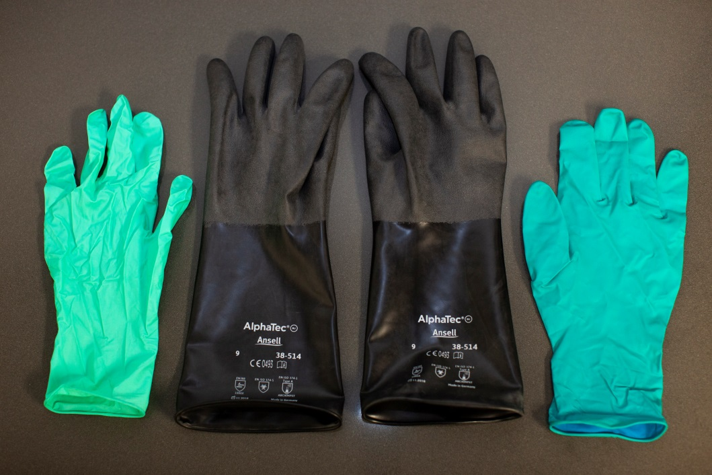  Figure 2 Selected gloves for hydrofluoric acid work. Left—disposable neoprene (Ansell® NeoPro® NEC-288, Size L). Middle—reusable butyl (Ansell® AlphaTec® 38-514, size 9). Right—disposable neoprene/nitrile double layer (Ansell® Microflex® 93-260, Size L).  Reusable  An example of reusable gloves which combine good HF protection with excellent ergonomics are the thinner types of unsupported (i.e. no fabric liner) butyl gloves. For example, EH&S has conducted a dexterity test on Ansell® AlphaTec® 38-514 (Figure 2; available from Grainger) and found the ergonomics and dexterity to be highly satisfactory.  Butyl gloves are very flexible, but the stretch is limited so it is important to select the correct size (Ansell® AlphaTec® 38-514 gloves are available in sizes 7-11; see manufacturer’s size guide.)  Disposable  The following neoprene and nitrile/neoprene double layer disposable gloves have better hydrofluoric acid resistance than nitrile or latex options. These gloves were also selected because they are longer in the cuff and made from thicker material than typical disposable gloves.  Neoprene: Ansell® MICROFLEX® NeoPro® NEC-288  Length 11.4 inches  Finger thickness 8.3 mil (0.21 mm), palm thickness 6.3 mil (0.16 mm)  - Available from Grainger  Nitrile/neoprene double layer: Ansell® MICROFLEX® 93-260  Length 11.22 inches  Finger thickness 7.9 mil (0.2 mm), palm thickness 7.9 mil (0.2 mm)  According to manufacturer, “Lower acceptable pinhole rate (0.65 AQL) for reliable protection against hazardous substances”  Available from Grainger  Selected Double Glove Combinations  The selected gloves described above may be combined into satisfactory double glove combinations. The following combinations have been assessed by EH&S to ensure ergonomics and dexterity are adequate for lab use.  Reusable butyl inner glove + disposable outer glove  Inner glove—butyl Ansell® AlphaTec® 38-514 (Figure 3)  Outer glove options (Figure 3):  - Disposable neoprene Ansell® NeoPro® NEC-288; OR  - Disposable neoprene/nitrile double layer Ansell® Microflex® 93-260  - EH&S found that for these specific glove combinations, a size L outer glove fit over a size 9 inner glove. Other sizes of inner glove were not tested.  - Both outer gloves shown are excellent, but the combination using Ansell® NeoPro® neoprene disposable gloves was found to have a distinct flexibility advantage.  Should be a satisfactory choice for most hydrofluoric acid work.  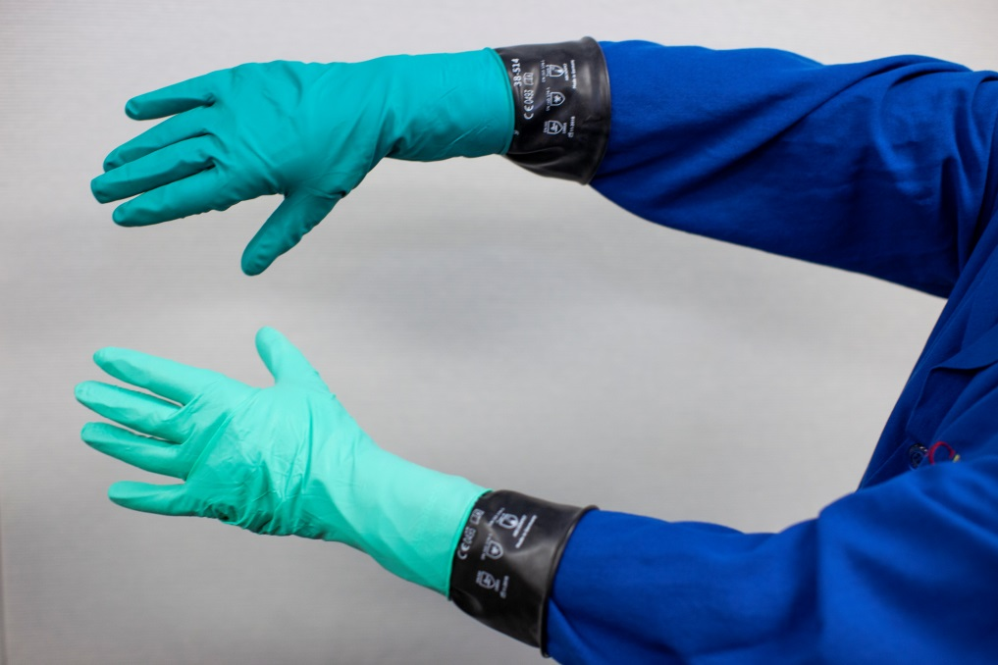  Figure 3 Inner glove – butyl (Ansell® AlphaTec® 38-514, size 9). Top—outer glove is disposable neoprene/nitrile double layer (Ansell® Microflex® 93-260, Size L). Bottom—outer glove is disposable neoprene (Ansell® NeoPro® NEC-288, Size L).  Select disposable inner glove + disposable outer glove combinations  Inner and outer gloves—disposable neoprene Ansell® NeoPro® NEC-288  - The most flexible and dexterous combination  - Gloves have good stretch, which makes exact sizing less critical than for other combinations.  - EH&S tested size L over M, and size L over L and both were satisfactory. Other size combinations were not tested.  Inner glove—disposable neoprene/nitrile double layer Ansell® Microflex® 93-260. Outer glove—disposable neoprene Ansell® NeoPro® NEC-288.  - Slightly less flexible and tactile, but still satisfactory.  - The inner neoprene/nitrile double layer glove may provide slightly wider chemical resistance than an inner neoprene glove; consult manufacturer for details.  - EH&S tested size L over L, which proved satisfactory. Other size combinations were not tested.  - Wearing the neoprene/nitrile glove outside the neoprene glove should not make any difference to the hydrofluoric acid resistance. However, EH&S tests found this combination to be harder to put on and take off, and to have slightly worse ergonomics.  Using neoprene/nitrile double layer Ansell® Microflex® 93-260 as both inner and outer gloves was tested, but the dexterity and ergonomics were not satisfactory on account of a lack of flexibility.
PPE: Laminate Film Gloves | Laminate film gloves (e.g. North Silver Shield®/4H®, Ansell Barrier®) provide good resistance to hydrofluoric acid and a wide range of organic and inorganic chemicals. Unfortunately, laminate film is not an elastic material, so the ergonomics are poor. Furthermore, laminate film has a shiny low friction surface, so grip is not the best and is very poor on wet surfaces. Due to the thinness of the material, extra care should be taken to avoid mechanical damage and holes.  Laminate film gloves worn alone (i.e. not double gloved) are NOT recommended except in an emergency situation (e.g. when assisting the decontamination of an exposed person). Laminate film gloves worn alone should be disposed after use.  For protection against HF in the presence of organic solvents incompatible with butyl, laminate film gloves (e.g. Ansell Barrier, #02-100) may be worn as a disposable outer glove, with a reusable butyl glove (e.g. Ansell AlphaTec 38-514) inner glove. The laminate film glove has to be on the outside, because incompatible organic solvents (e.g. aliphatic and aromatic hydrocarbons, chlorinated solvents) will permanently damage butyl gloves by diffusing into the butyl and swelling it. With this combination, care must be taken to avoid damaging the outer glove and creating pinholes.  A dexterity test by E&HS (inner glove—Ansell AlphaTec 38-514, butyl, size 9; outer glove—Ansell Barrier, #02-100, size 9) indicated that ergonomics and dexterity are not good but should be just about manageable for laboratory applications.  If HF is used in conjunction with butyl-incompatible liquids while wearing laminate film gloves over butyl gloves, both the inner and outer gloves should be disposed of if the outer laminate film glove develops a leak and liquid is suspected to have entered. Please note, incompatible organic solvents (e.g. hydrocarbons) may diffuse into butyl and damage its properties, even if there is no visible degradation.  Laminate film gloves can also be used as an inner glove when disposable neoprene or neoprene/nitrile combination multilayer gloves are used as the outer glove. This combination should give acceptable protection from combined chemicals including HF.  A dexterity test by E&HS (inner glove— Ansell Barrier 02-100 inner glove (size 9); outer glove— Ansell Microflex 93-260 nitrile/neoprene outer glove (size L), and an Ansell NeoPro NEC-288 neoprene outer glove (size L)) indicated that ergonomics and dexterity was poor, due to lack of flexibility and bunching of the inner glove.  If laminate film gloves are used as inner gloves, they may be reused a few times if carefully looked after (“semi-reusable”). The gloves should be decontaminated after each use, carefully stored to prevent damage, and be checked for pinholes before use. They should NOT be reused if there is any concern that they may have been exposed to chemicals which may have been absorbed into the gloves or degraded the material.
Lab-Specific Glove/PPE Rules | [It is strongly recommended that specific glove combinations be specified in this section. Selection should be based on the rules and recommendations given in the previous sections. If hazards are purely aqueous, or there are organic liquids present but none which are incompatible with neoprene or butyl, then it is recommended to pick glove combinations from the section “PPE: Glove recommendations”.]  [Add details of any lab- or procedure-specific PPE rules/requirements.]
Exposure Control | Always purchase and use the lowest concentration of hydrofluoric acid which will work for the intended application.  All work which has potential to release hydrogen fluoride vapor or HF-containing spray or dust shall be conducted in a chemical fume hood. Under NO circumstances shall hydrofluoric acid of >5% concentration be used outside of a fume hood. This includes the operation of diluting concentrated hydrofluoric acid even if the final concentration is less than 5%. Please consult the CHP for detailed information on engineering safety controls, including fume hoods.  Hydrofluoric acid of ≤5% concentration may be used outside of a fume hood ONLY if ALL the following conditions are met:  - An overriding technical reason prevents use of a fume hood.  - The acid is not heated in any way.  - The room has adequate ventilation.  - The surface area of acid exposed to the atmosphere is not excessive.  - The work is of limited duration.  Adequate secondary containment (e.g. polyethylene or polypropylene tray) shall be employed under all HF work in order to contain spillage.
Decontamination | Clean and decontaminate all work areas and equipment after use.  Visible HF contamination should be initially wiped off, taking care to safely dispose of contaminated wipes as hazardous chemical waste. After removal of visible droplets, remove/neutralize any residual HF by thoroughly washing with copious amounts of water. If washing is not practical, wipe down with excess saturated sodium bicarbonate solution.  [Add details of specific decontamination/cleaning procedures, if needed.]
Work Practices | HF shall NOT be used while working alone.  Purchasing, working, and storage quantities should be kept as small as possible. Any unused materials should be immediately and appropriately disposed of as hazardous chemical waste.  [Add details of specific work practices you will be using in the lab under this SOP. Work practices are rules which personnel are required to follow to be safe, for example, that certain procedures may not be done out-of-hours or alone. Work practices can also be a defined way of doing things, for example, diluting concentrated acids by pouring the acid slowly into water while stirring, with a prohibition on pouring water into the acid.]
Experimental Procedures | [Add details of specific experimental procedures/protocols you will be using in the lab under this SOP]
Waste Disposal | Dedicate a thick-walled polyethylene waste bottle solely for hydrofluoric acid waste. Do NOT use glass bottles as they will be corroded. Labeling of hydrofluoric acid waste shall be explicit: “Danger—Hydrofluoric Acid (HF)”. Do NOT just write HF, and do not just write hydrofluoric acid in case it gets confused with hydrochloric acid. Use both the name and the formula, and ensure labelling is BOLD and LEGIBLE. Store waste bottles in secondary containment and ensure they are free of external contamination.  Some labs may have protocols for disposal of hydrofluoric acid by neutralization with calcium carbonate or calcium hydroxide to produce calcium fluoride, which is extremely insoluble and therefore non-toxic. Protocols of this type should be approved by Hazmat (hazmat@usc.edu) and should be entered into this SOP.  Due to the high contact hazard, solid waste contaminated with hydrofluoric acid should be disposed of with the utmost care. Use sturdy polyethylene containers with a tight-fitting lid.  For lightly contaminated waste, sturdy polyethylene bags may be appropriate if multiple bagging is used and the outer bag is taped closed. Clearly label waste containers as described above.  Follow all EH&S directions (hazmat webpages, fact sheets, CHP) when disposing of hazardous chemical waste. Email hazmat@usc.edu if you have questions that are not answered by EH&S online resources.  [Add details of any lab-specific waste disposal rules.]
Emergency Equipment/ Supplies | Hydrofluoric acid shall only be used when there is a combination safety shower/eyewash located in the same room.  Labs using hydrofluoric acid shall have a hydrofluoric acid compatible spill kit. Absorbents must be rated by the vendor as suitable for hydrofluoric acid. Recommended absorbents are:  - PIG® Hydrofluoric Acid Neutralizing Loose Absorbent  - Amphomag®. Hydrofluoric acid labs should keep ≥ 25lb on hand. Note that this material is also suitable for dealing with spills of almost any liquid, not just hydrofluoric acid. The only downside is that there may be appreciable heat evolution when neutralizing concentrated acid.  Besides absorbent, a spill kit should contain at minimum: hydrofluoric acid resistant gloves (e.g. laminate film or butyl), large sturdy polyethylene bags for waste, large scoop for dispensing absorbent (if not in shaker bottles), polypropylene dustpan and brush for picking up absorbent, chemical splash goggles, chemical resistant sleeve apron, and hazardous waste labels. An extra face shield may be provided in the spill kit, but normally the lab’s face shield should suffice if stored in an accessible location.  Instead of assembling their own spill kit, labs may purchase a ready-to-use hydrofluoric acid spill kit.  Labs using hydrofluoric acid shall have hydrofluoric acid first aid supplies available. Hydrofluoric first aid supplies shall, at a minimum, consist of:  Calcium gluconate gel (e.g. Calgonate® Gel). (This is a time sensitive material and shall be replaced before expiry.)  - HF-resistant gloves to assist with decontamination of victims (e.g. butyl gloves or laminate film gloves (North Silver Shield®/4H®, Ansell Barrier®)).  - Printed copy of Calgonate® first aid instructions (http://www.calgonate.com/safety_info.php)  - Printed copy of Honeywell® Recommended Medical Treatment for Hydrofluoric Acid Exposure document (to give to emergency medical responders) (https://www.honeywell-hfacid.com/wp-content/uploads/2014/06/2734-Medical-Treatment-for-HF-Acid-Exposure_v7-WEB.pdf)  Calcium gluconate eyewash is recommended but not currently mandatory. If calcium gluconate eyewash is provided, it shall be located in an accessible location and shall be replaced before the expiry date. Calcium gluconate eyewash is to be used after at least 5 minutes of irrigation with a regular eyewash, as per Calgonate® first aid instructions (http://www.calgonate.com/safety_info.php).  The provision of calcium gluconate eyewash shall not be used in lieu of a plumbed eyewash located in the same room as the HF work.
Safety Eyewash/Shower Usage | Any bodily exposure to HF is to be considered an emergency requiring immediate action. It is ESSENTIAL to IMMEDIATELY employ the safety shower/eyewash in the event of being splashed with HF. Contaminated clothing MUST be removed under the shower even though that may be embarrassing. Significant hydrofluoric acid contamination of skin may result in death or irreversible serious injury unless removed with the utmost speed.  All personnel working in labs which use HF (including personnel who do not use HF themselves) shall read and familiarize themselves with the Calgonate® first aid instructions for hydrofluoric acid exposure (http://www.calgonate.com/safety_info.php), which are hereby incorporated into this SOP by reference.
Spill Response | Chemical spill clean-up shall not be attempted if lab personnel do not have proper training and experience, necessary spill kit supplies, and/or appropriate personal protective equipment. Before starting work, review the Spill Response and Clean-Up web page and Section 10 of the CHP. All personnel operating under this SOP shall familiarize themselves with this information and shall re-review these references at least annually.  Refer to the EH&S Chemical Spill Kit Guide Sheet for guidance on appropriate spill kit materials. For additional information on proper spill clean-up, please reference the USC EH&S HF Safety Fact Sheet. Appropriate HF accident response and first aid is outlined in the USC EH&S HF Safety Fact Sheet. By signing this SOP, personnel acknowledge that they will download, store, read, and thoroughly familiarize themselves with HF accident response and aid outlined in the USC EH&S HF Safety Fact Sheet.  Call DPS for all spills, even if they get cleaned up by lab personnel. DPS will pass information to the EH&S and Hazmat on-call system. If needed, trained staff will be sent to the lab to clean and decontaminate the spill. If lab personnel clean the spill themselves, notification should still be made as lab safety specialists may wish to follow up with a routine safety investigation.  Major spills outside a fume hood SHALL NOT be cleaned by lab personnel. Evacuate the area, restrict access, call DPS. All spills of hydrofluoric acid outside of a fume hood shall be assumed to present a respiratory hazard unless the acid is very dilute (<5%). If hydrofluoric acid is spilled outside of a fume hood, evacuate the lab and call DPS. If safe to do so, quickly dump adsorbent on the spill before vacating the lab, to prevent the spill from spreading further and to facilitate subsequent Hazmat cleanup. Do NOT attempt to dump adsorbent on the spill if doing so may result in unsafe exposure to HF vapor (e.g. from large spill of concentrated acid).
Emergency Response | Before starting work, review the EH&S emergency webpage and the 1-2-3 poster. Ensure that the 1-2-3 poster is posted in the lab. All personnel operating under this SOP shall familiarize themselves with these documents and webpage.  All personnel operating under this SOP shall have downloaded and read Section 10 of the CHP (“Emergency Response / Injury and Illness Reporting”). This section provides information on chemical exposure response, spill response, and injury reporting.  The 1-2-3 poster, CHP Section 10, and the EH&S emergency webpage are hereby incorporated into this SOP by reference.  All personnel operating under this SOP shall have the DPS emergency number programed into their phone (UPC 213-740-4321; HSC 323-442-1000).  Phone the DPS emergency line in an emergency!! DPS have 24 h/day immediate communication access to primary and backup personnel on the EH&S and Hazmat on-call rota. Do NOT call the EH&S general phone line or individual EH&S personnel in an emergency as access is not guaranteed.

SOP Acknowledgement
The undersigned acknowledge by their signature that they:
- Have read, understood, have access to, and agree to abide by this SOP, AND;
- Have read and understood the emergency response resources incorporated into this SOP by reference (“1-2-3 poster”, CHP Chapters 6 and 10, and EH&S emergency webpage), AND;
- Will download, store, read, and thoroughly familiarize themselves with safety data sheets (SDSs) for all the hazardous materials they intend to use within the scope of this SOP.
Name | USC ID | Email | Signature | Date

Internal Training Record
If hazards are high or complex, or personnel have limited prior experience or training, then hands-on training should be provided on the contents of this SOP. For convenience, the training may be documented using this form, although PIs are free to keep internal training records in other formats if desired. Training may be conducted by the PI, or the PI may delegate a suitably experienced and knowledgeable lab member (e.g. lab manager or senior postdoc) as the trainer. If delegated, the PI still retains management responsibility for the quality and adequacy of the safety training.
Trainer name |  | Trainer position
Trainer USC ID |  | Trainer email
Trainee #1 name |  | Trainee #1 USC ID
Trainee #1 email |  | Trainee #1 signature
Trainee #2 name |  | Trainee #2 USC ID
Trainee #2 email |  | Trainee #2 signature
Trainee #3 name |  | Trainee #3 USC ID
Trainee #3 email |  | Trainee #3 signature
Trainee #4 name* |  | Trainee #4 signature
Trainee #4 email |  | Trainee #4 USC ID
Date training started |  | Date training completed
Type of training (delete as appropriate) | Initial training  Refresher training | Type of training (delete as appropriate) | Classroom training  Hands-on laboratory training
If refresher training, provide date of initial training |  | If refresher training, was the initial training hands-on in the lab? | YES NO
Signature of trainer confirming the above named trainees have successfully completed safety training on the contents of this SOP (and any additional subjects listed below)
Date of signing by trainer
Additional subjects covered by safety training
* If there are more than four trainees, please append an additional sign-in sheet.

Section 6 for identification and Section 8 for safe working practices.
“Lower” hazard not “low” hazard. All HF-containing materials are significantly hazardous and none can be accurately considered as low hazard.
If the vendor specifies an expiration date or maximum safe storage time of less than two years then that should be followed.
These specific gloves were selected by EH&S based on a combination of known characteristics of the glove materials, publicly available manufacturer’s information, and a dexterity/ergonomics assessment to ensure practicality for laboratory use.

